ADITYA MISHRA

STATISTICAL INFERENCE

MATH-3316-003

MINI PROJECT #2

After changing TG to CG and CG to TG at 99%.

Codes:

Plots:

Figure: Show Q-Q plots.

Results based on book:

Figure: Shows the mean procedure as in the book

After changing TG to CG and visa-versa at 88%.

Codes:

Results based on book:

Figure: Shows the mean procedure as in the book

Plots based on book:

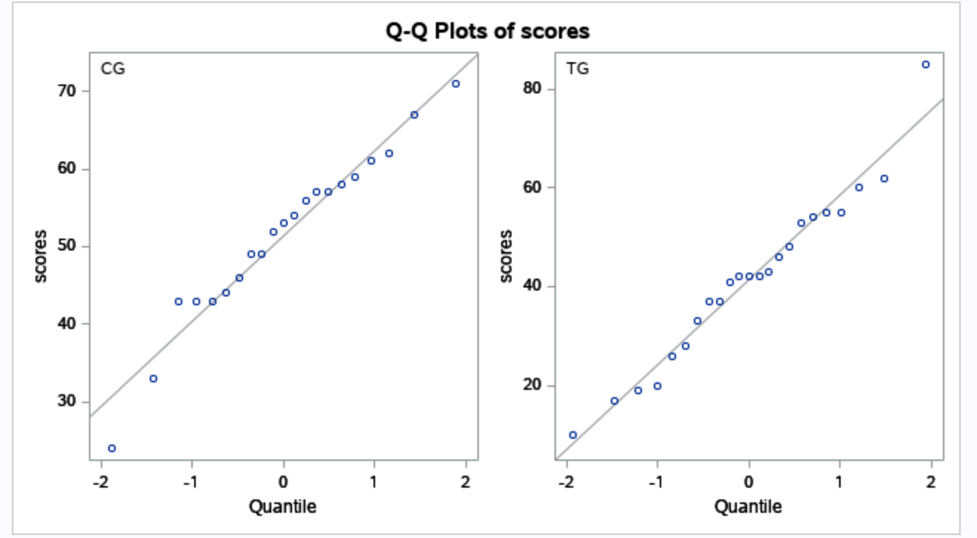

Figure: Show Q-Q plots.

Description Below.

Here, From the graph it looks like there is mild outlier in the control group but no deviation from Normality serious enough to forbid use of t procedures. Our quantile plot of these graph confirms that our distribution is approximately normal based on 88% and 99% whereas the scores of CG or control group looks a little higher than TG or treatment group. The confidence interval of these groups looks like around 10 which means the mean improvement of about 10 points with some +-1 error.

Problem Number 2:

Results:

Results locating the residual from the book i.e. -0.34. It is in the row number 4 and column name residual.

Graph plots similar to the book.

